Videos from 35

**Docker architure**

container deploy on the docker platform , but there is container runtime will run container, when you deploy the java application on to the container, the container will not run the java application, beca

use the java run time is not running on the container.

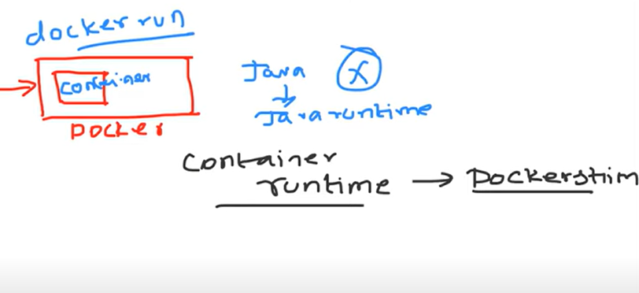

Container platform there is no java runtime, java will not work on container platform.

Docker has support one Dockershim

for kubernetes , need to create the multiple master nodes and multiple worker nodes.

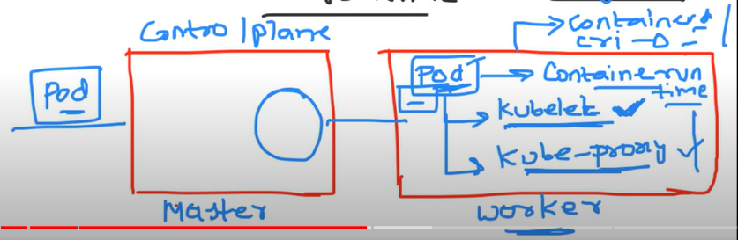 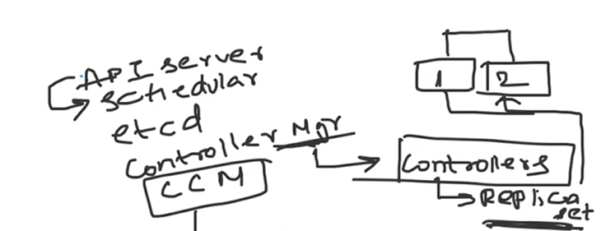

Kubernetes top order to use in the market

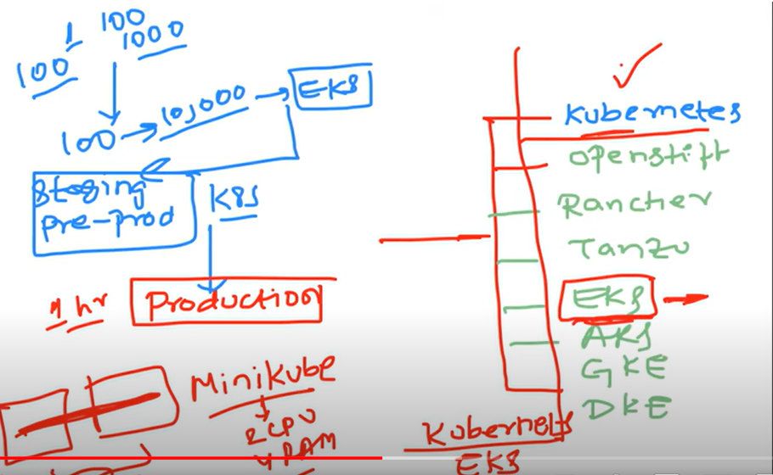

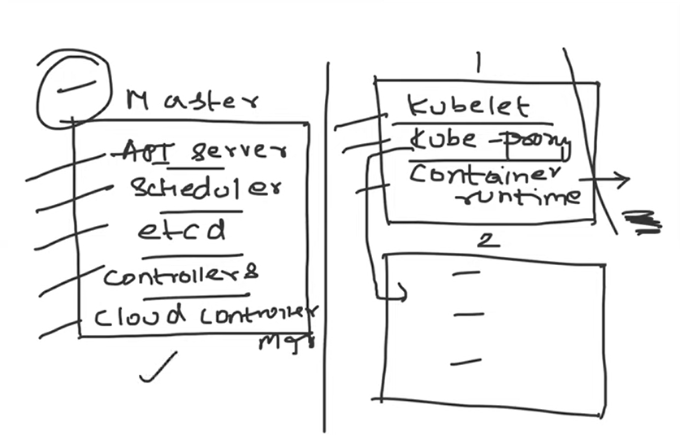

DEvops manage the hundreds of clusters in the production

The tools use to create the kubernetes cluster

Kubernetes operatons dealing use the KOPS

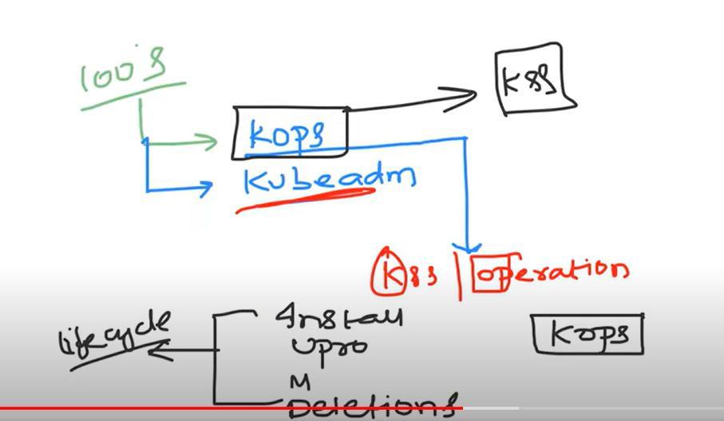

Moving from Docker to kubernetes

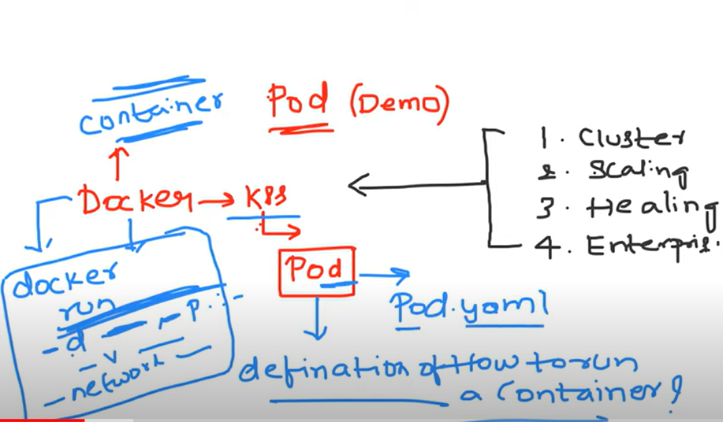

Pod can create one container or multiple containers

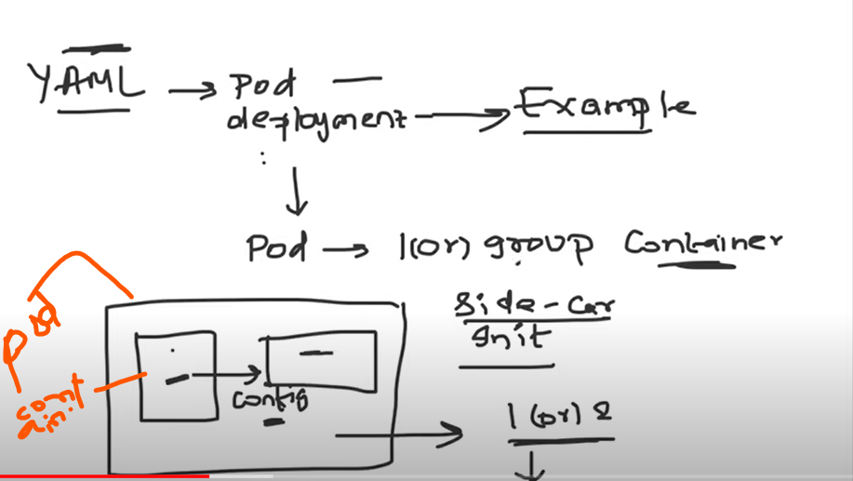

Container share the network/storage in the pod

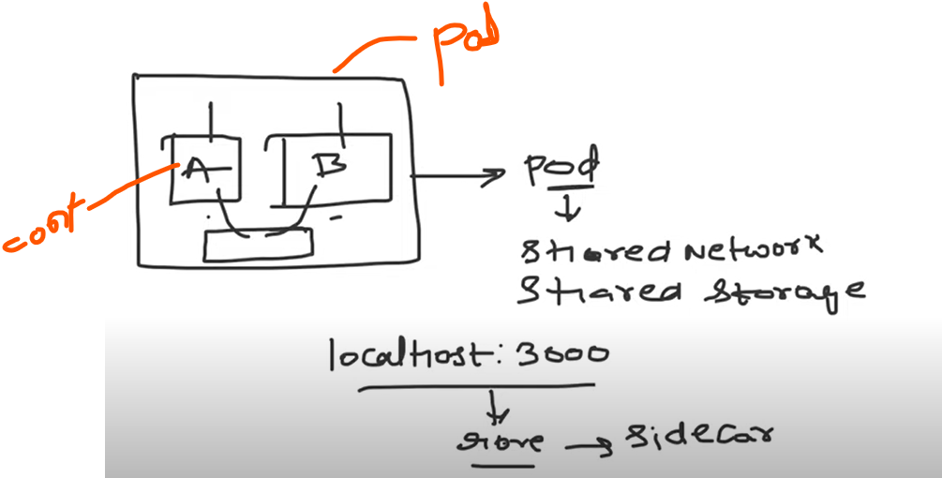

Kubernetes allocates cluster ip address to this pod

Kubernetes allocated cluster ip address for pods not for container to application access.

Cluster ip address generated by kubeproxy

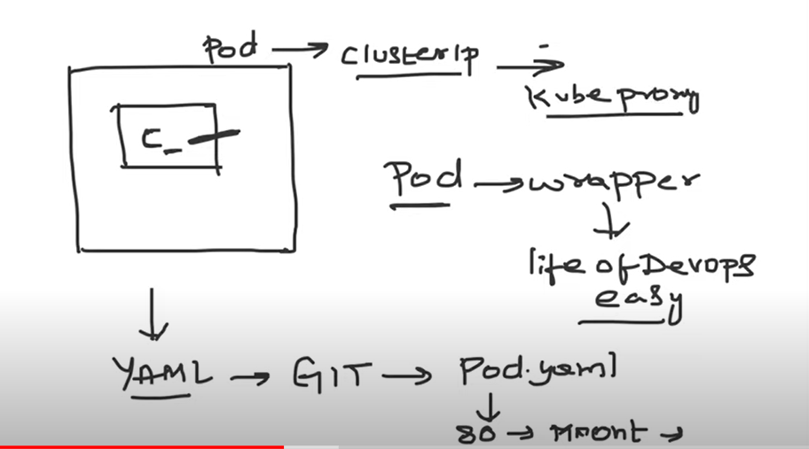

Kubectl command line for Kubernetes

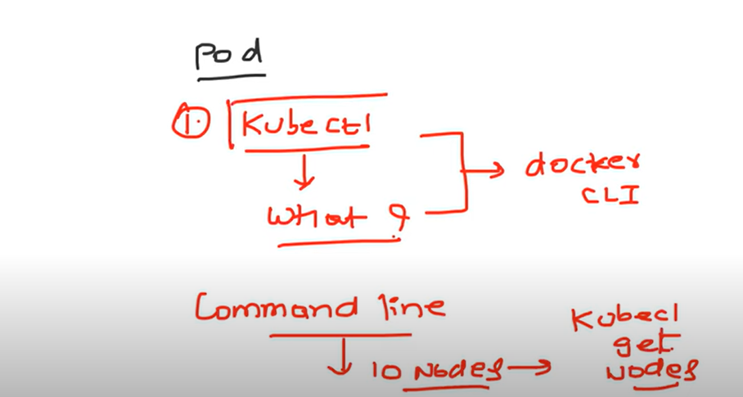

For create the cluster on local machine , use the minicube free, if you use the KOPS it will be chargeable

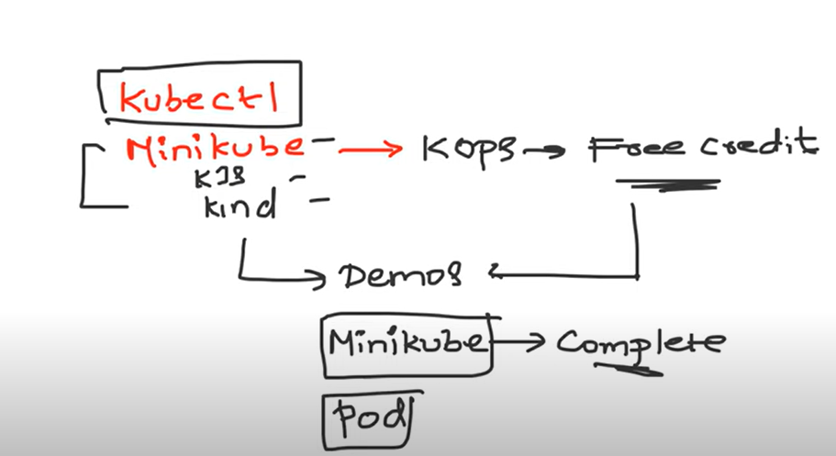

Kube ctl installation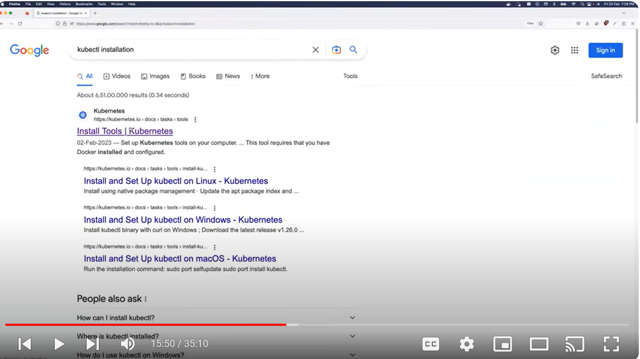

Choose the platform

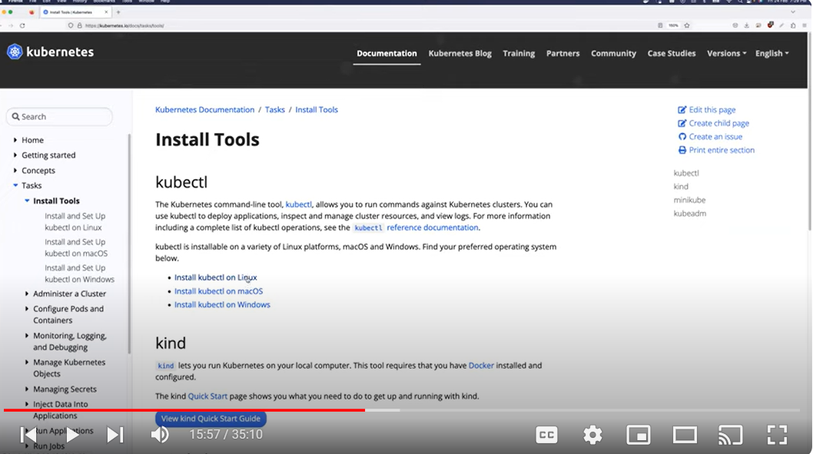

Search for minicube

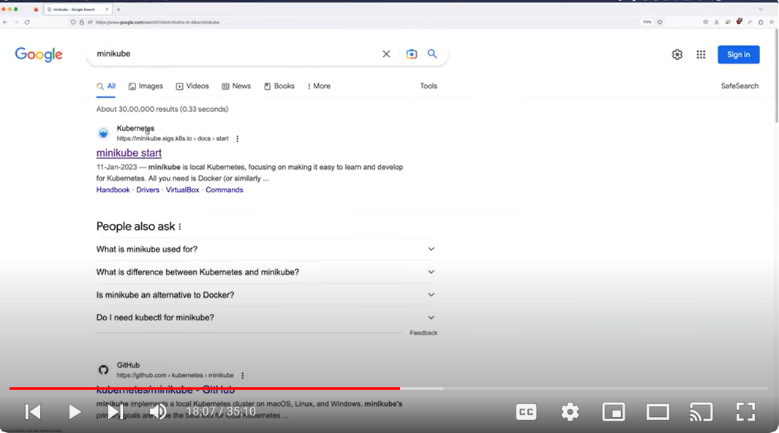

Installation

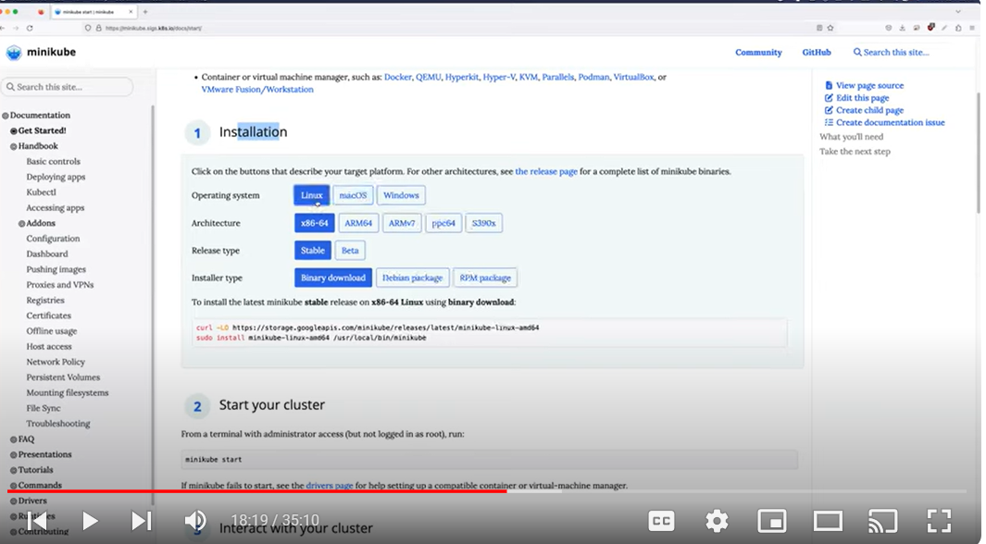

Install cluster

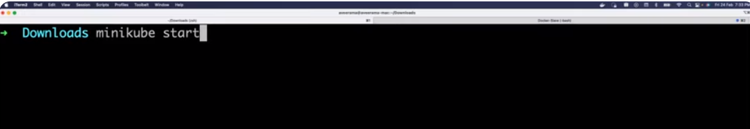

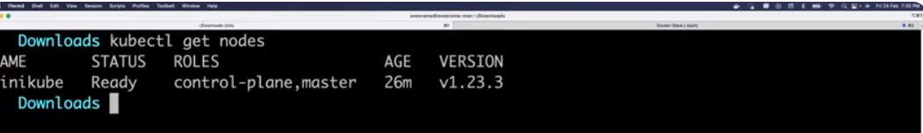

Install pod



Copy the yaml file

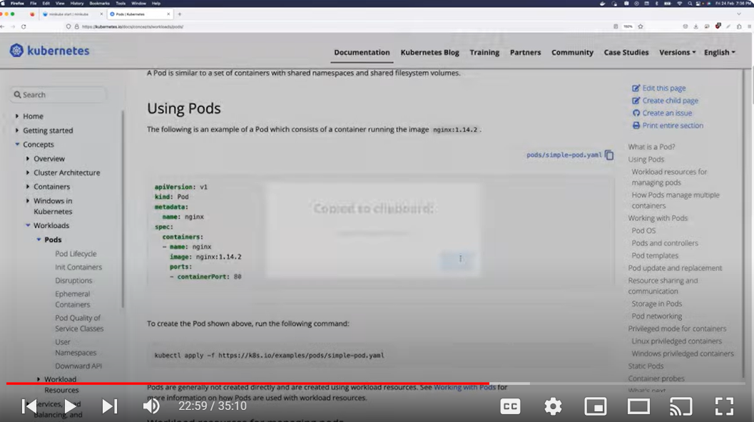

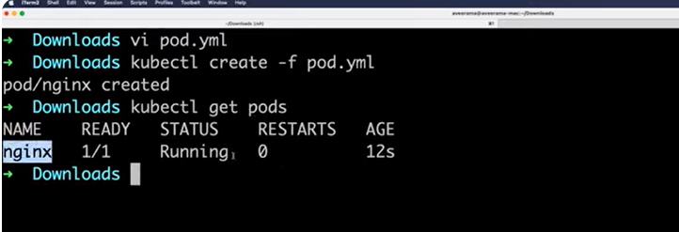

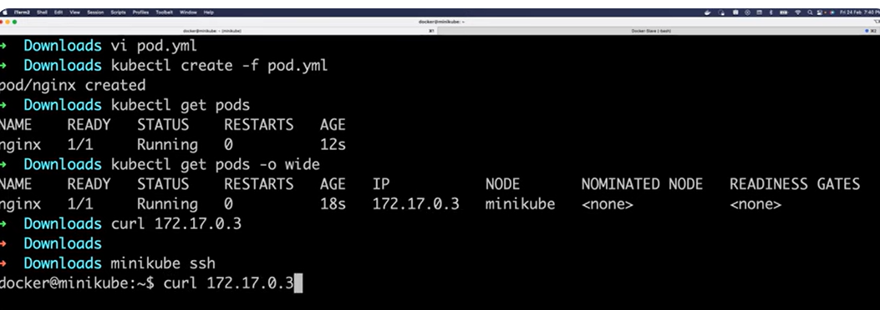

Kubectl commands

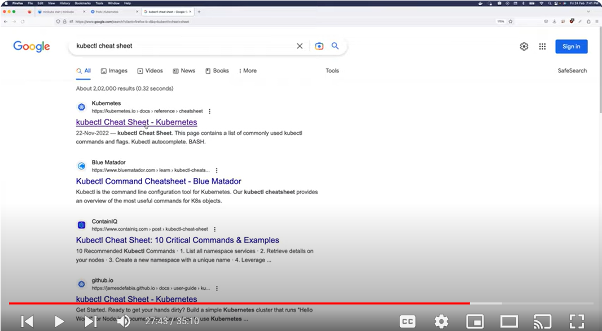

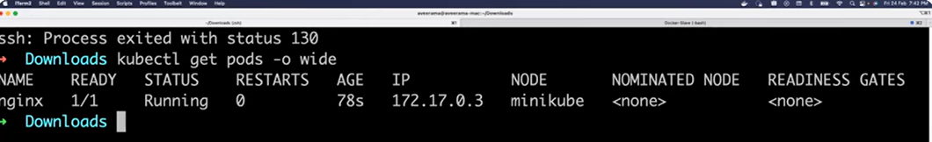

Delete the pod

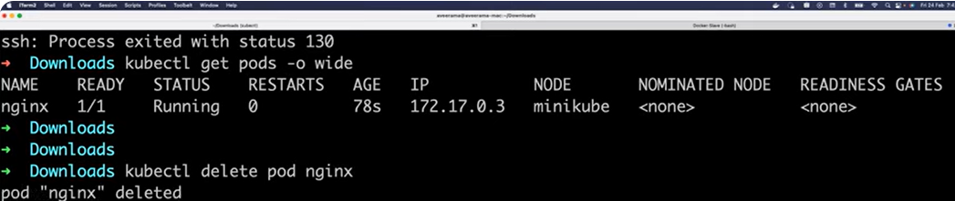

Interview question

How do you debug a pod

Ans : use the kubectl describe pod podname command, then I will get the all the details in the pod (any error in the pod or pod is running

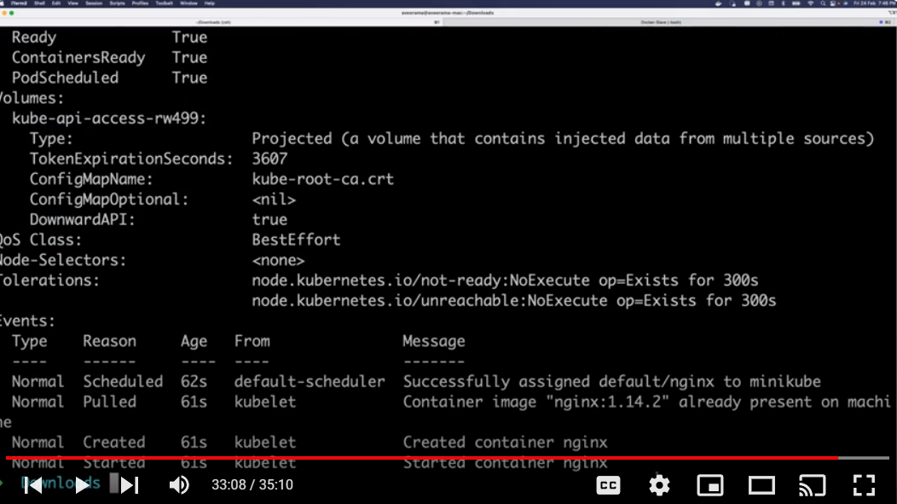

Display the logs

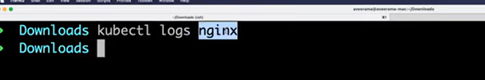

Video 34

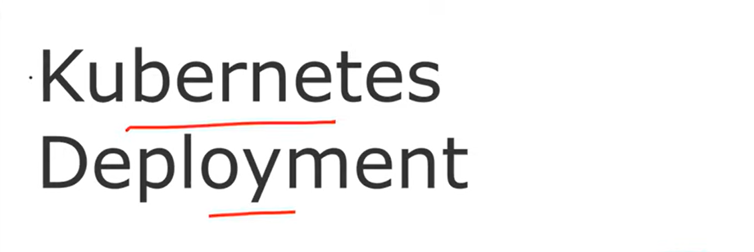

Difference between container, pod, deployment

Use the docker command and create the container

Use the yaml file create the pod, pod does not have capbity to auto healing and auto scaling

Use the deploy and deploy the pod with auto healing and auto scaling’

Kubernetes suggested don’t directly deply the pod, use the deployment and deply the pod.

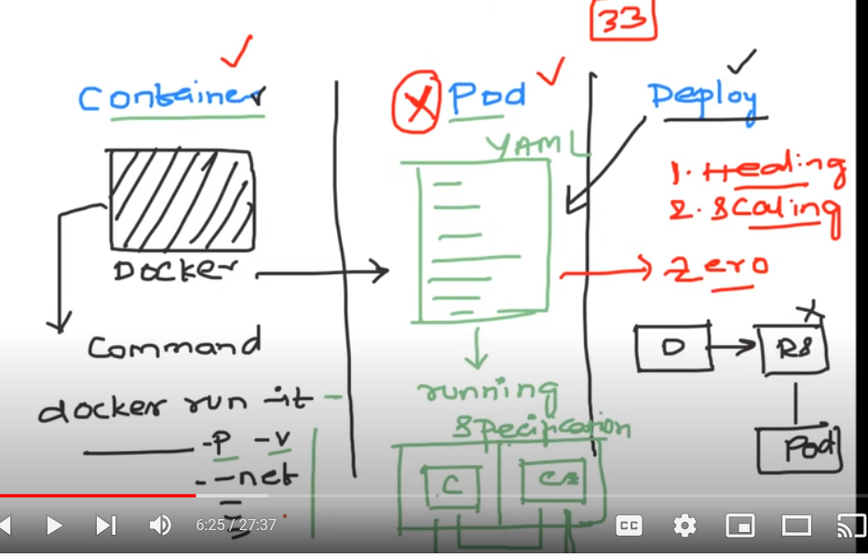

Pod deployment

You mentiond ex replica count as 2 in yaml manifest, then any reason user accidently delete the one pod

Kubernetes use the auto healing and automatically create one more pod based on the cotoler count used in the yaml file.

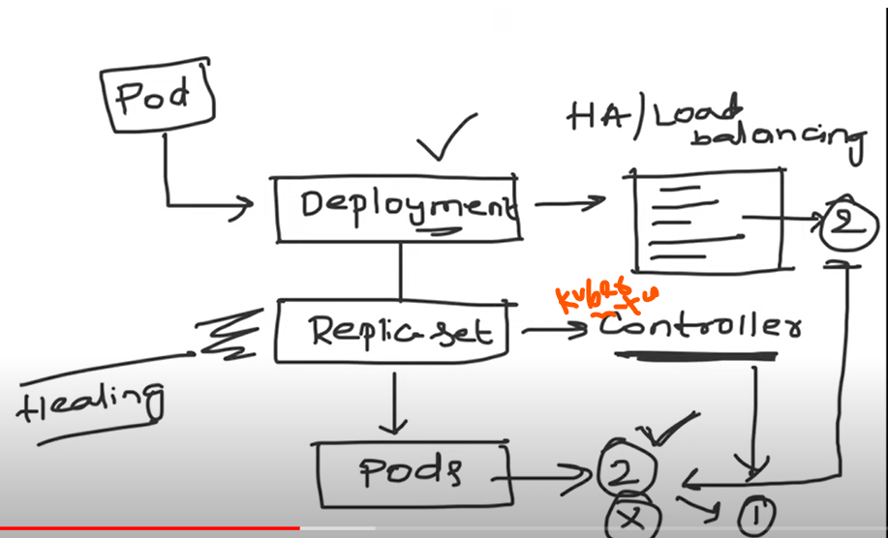

Replica set mange the pod count

Replica set manged by Controller are different type default controller and customer controller

Kubernetes provided Default contoler state ensure **actual state** is always same as **desired state**

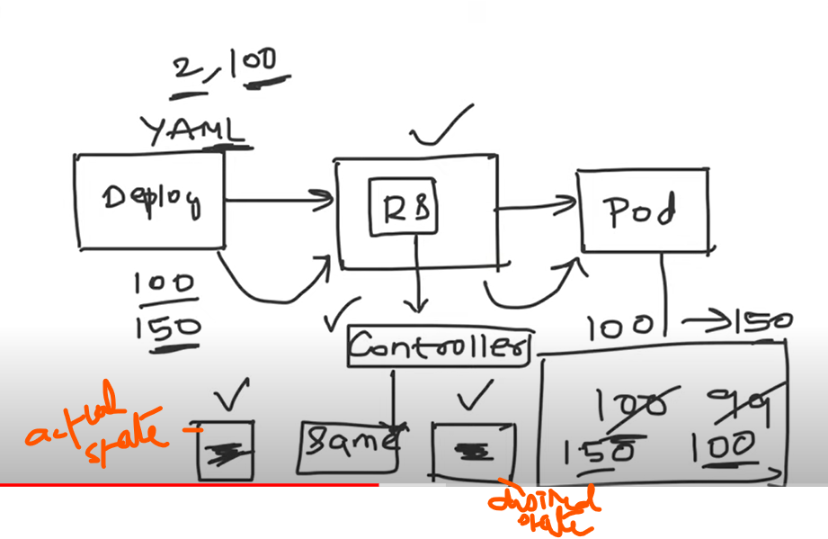

Interveiw quesiton: Deployemnt vs resplica set

Ans: When you create the deployment replica set created automatically which is respoonsible for tracking the controler behavier in kubernetes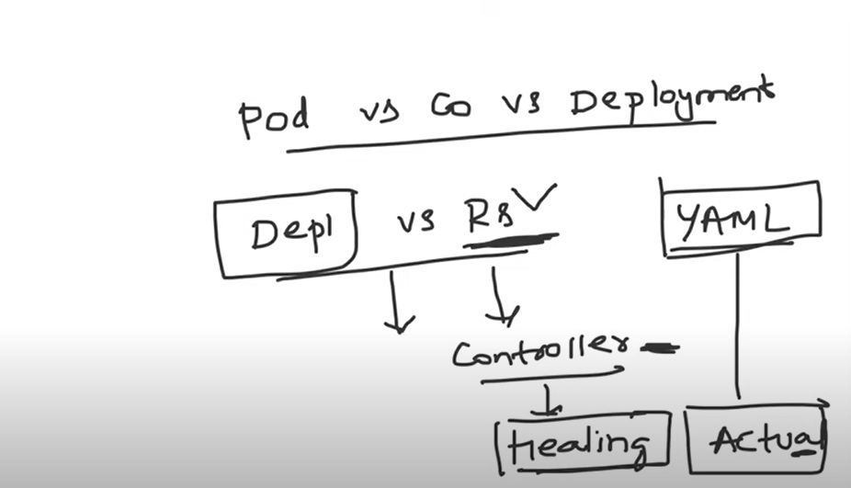

Already ruuning one pod on cluster get the details and delete from cluseter

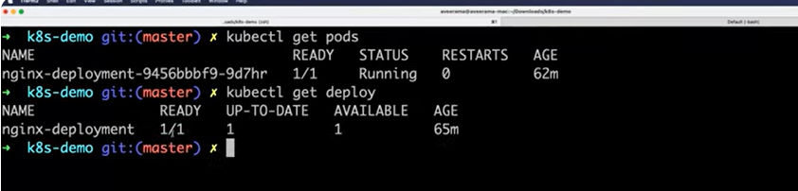

Check the get pods and get deployment details

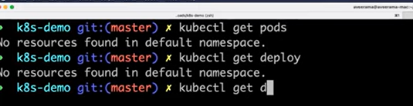

Interveiw: how can you get all resources are available in particular name space

In real world scenario use the kubectl get all, will get all the details

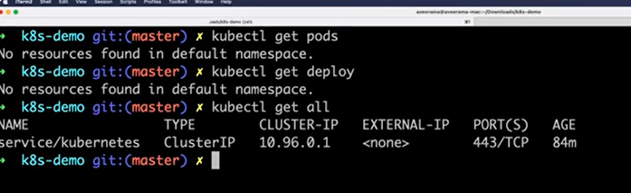

Kubectl get all -A

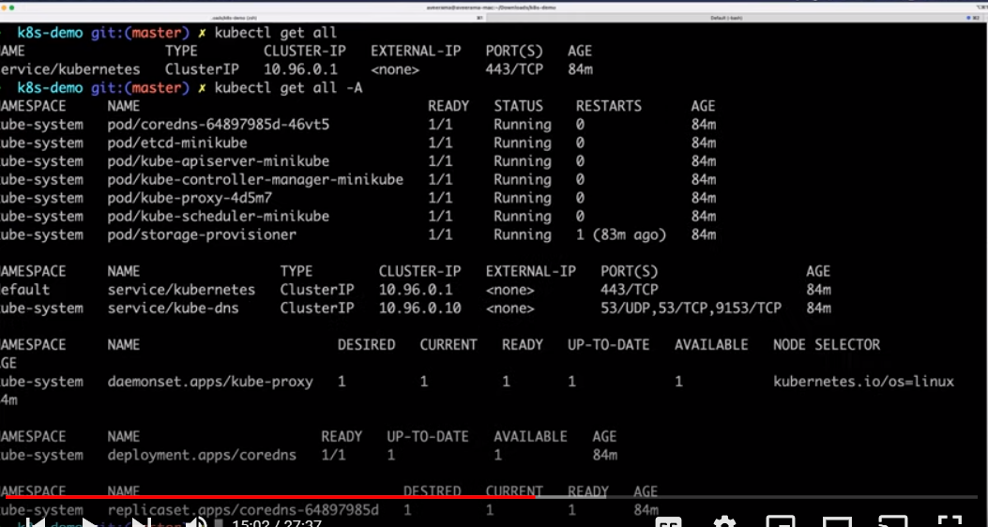

How to create the pod

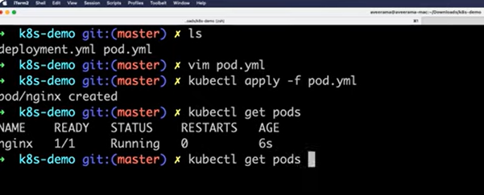

Get the pods and get the all details about pod kubectl tet pods –o wide

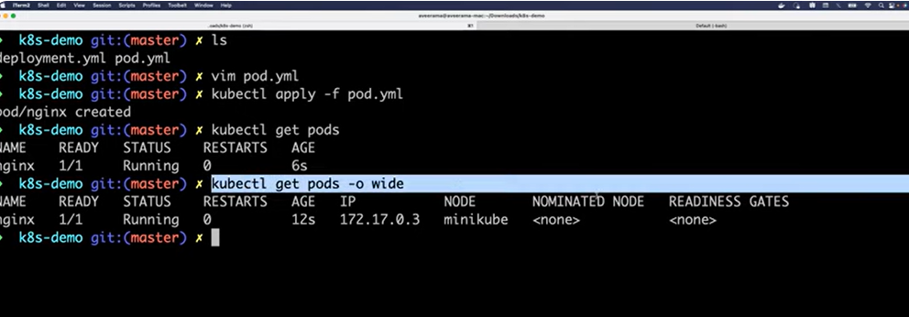

Loging to the minicube cluster to get the ip detaisl

If you are using remote cubernetes cluster use ssh –I <node name> <ipaddress of the node>

In the demo using the minicube cluster so use minicube ssh

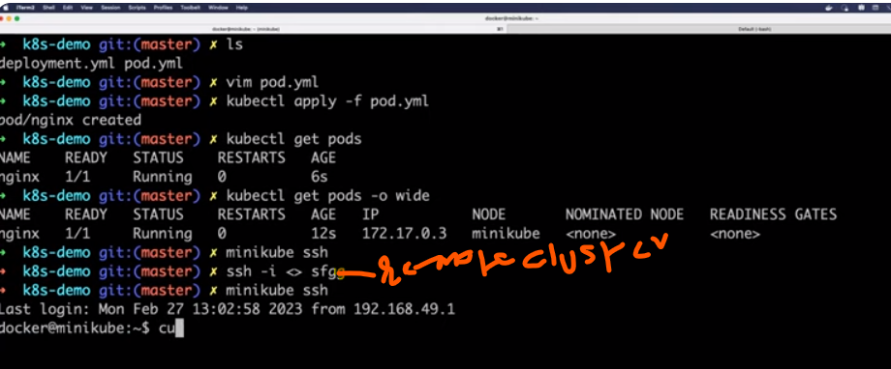

Some user or network issue because of the reason pod got deleted, but here not created correct resource, instead of pad you have to create the deploy

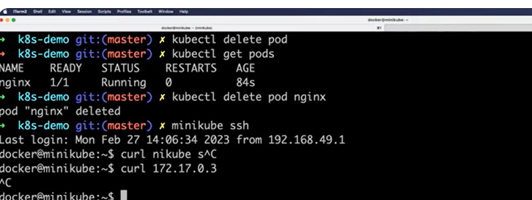

Kubernetes deployment

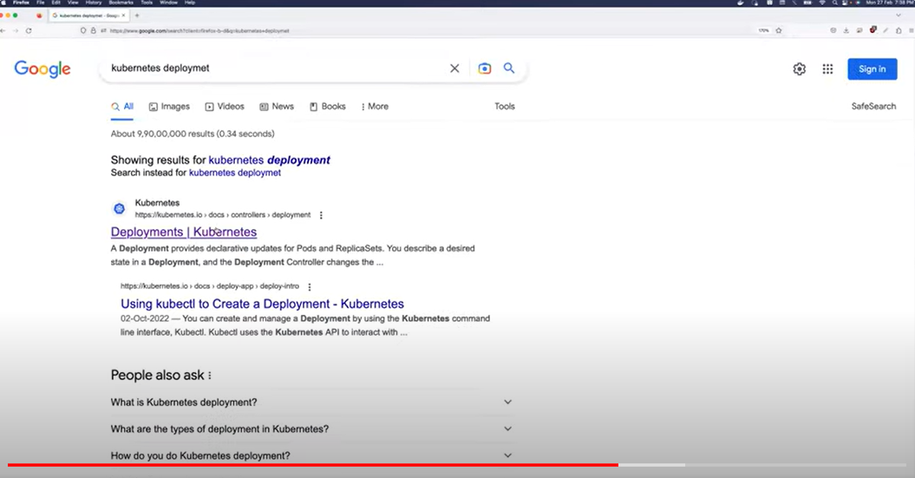

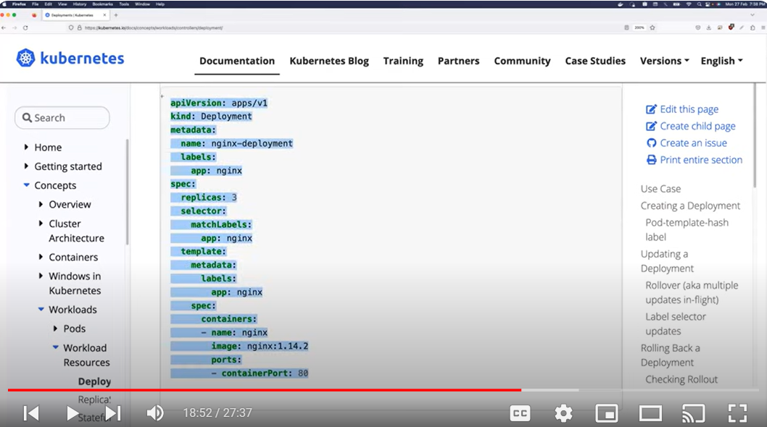

Below yaml file deployed to pod.

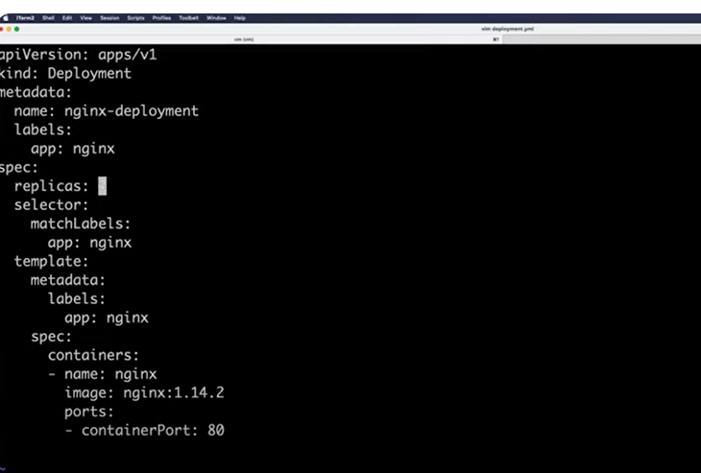

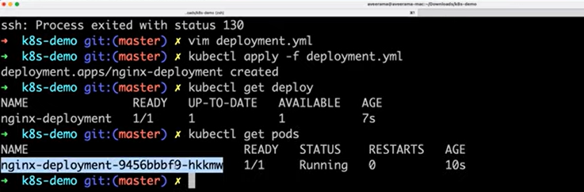

The above mentioned name created by yaml echo system (deploy--🡪replicaset..>pad)x

Deployment is an abstraction , you don’t have to create replica and you don’t have to create the pod.

Deployment will not do directly , deployment will take help of replica set and replica set is kubernetes controller.

Kubernetes controller is nothing but a go- language application that kubernetes written.

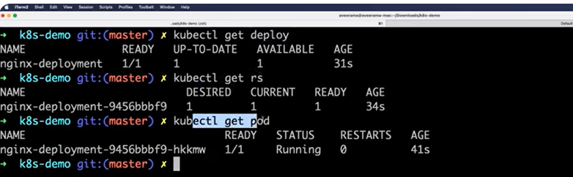

Pod get deleted

Kubectl delet pod <padname>

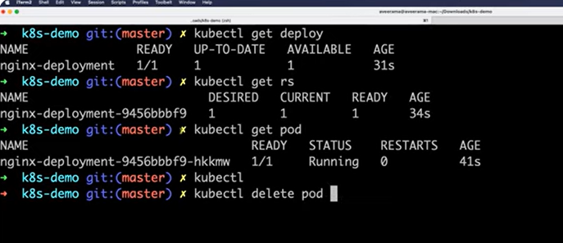

Get pad watcher, kubectl get pods -w

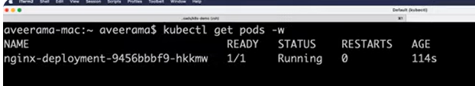

Afteter delete the pad, you can see the magic, pad(container creating)

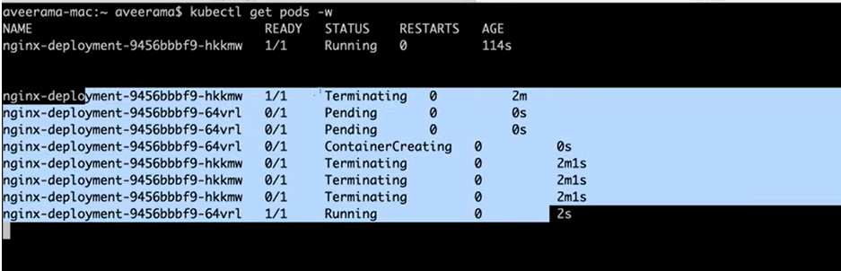

Use the kubectl get pods, then pod is running

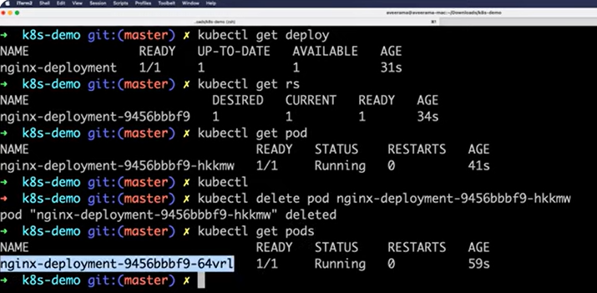

Increased the deployment (replica) pad count to 3

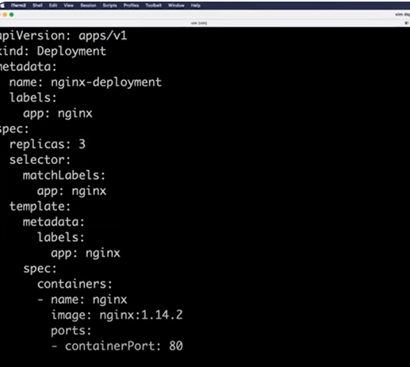

Apply the deployment to pod, then deployment configured

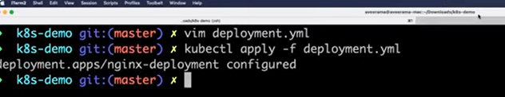

Get pod watcehr

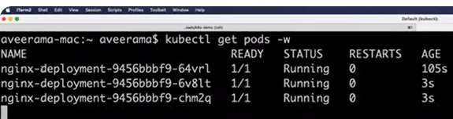

Deleted one of the pod

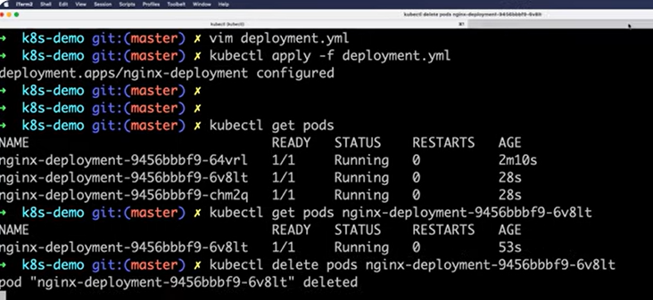

See the again the behavior same after delete the pod

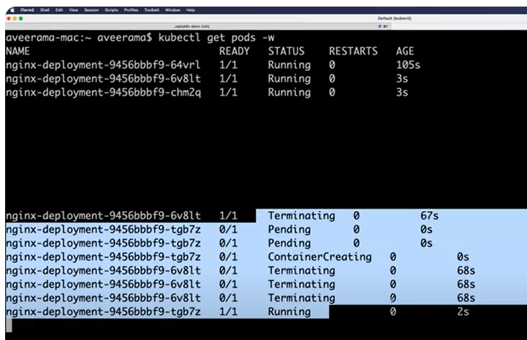

In real world you will create the deployement --🡪 replicate set…>pod

You can’t directly create the pod in kubernetes world

Search for more examples for kubernetes examples

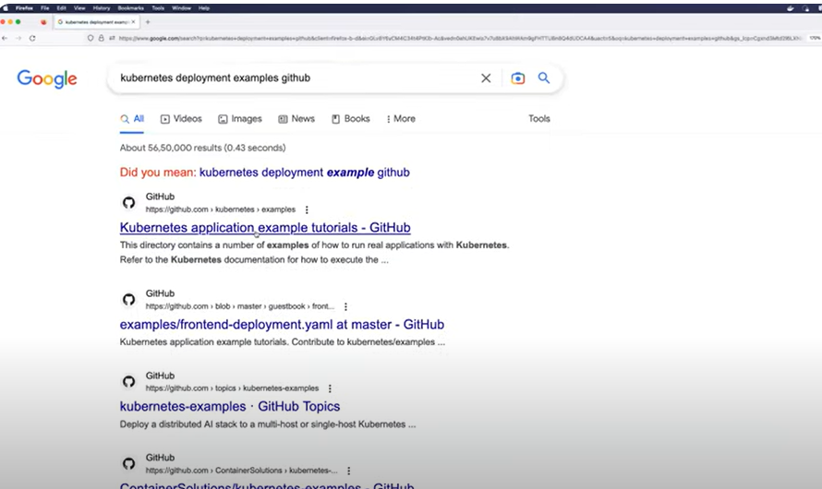

Day 35

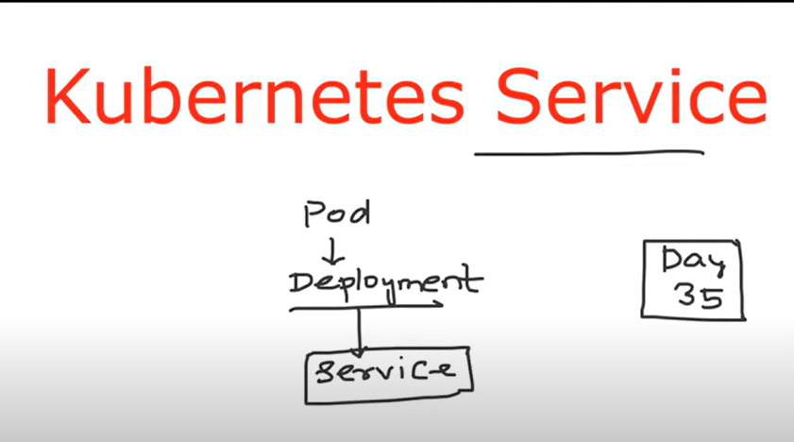

No services in kubernetes

Why moved from containers to pod, if container is deleted , there is no autlhealing capability, that is the reason it moved to pod.

If no service concepet in kubernetes, if you delete pad accidently then kubernetes immediately create the new paod with different ip address, then you already shared the ip address to different teams, so if new pad ipadress is changed , the users can’t access that pod, so because of that reason service concept introduced.

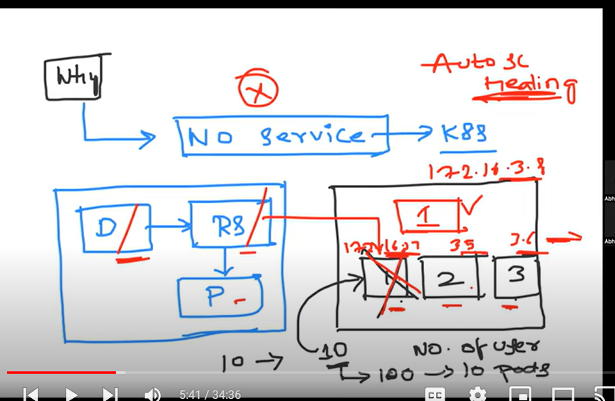

1. **Service introduced loadbalencing**

Here auto healing implemented but when new pod created the ip address will change and in real worl no body will share the ip address to users, so the real world companies (ex google.com) introduced loadbalancing concept.

In that above scenario , you will tell the users to don’t directly use the ip address, I will create the service (svc) on top of deployment, then you can use that service.

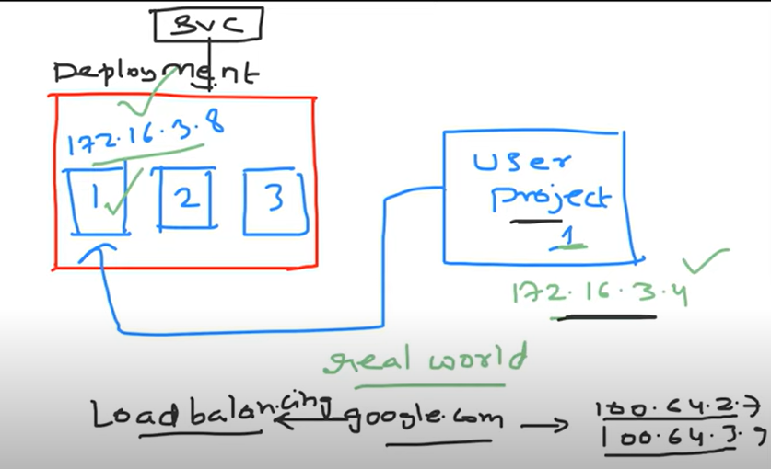

Instead of calling ip address, ontop of deployment create service , the service it access the load balancer. How to access the loadbalncer it is uses the kube-proxy.

As soon as you create the service, kubernetes will create the service name

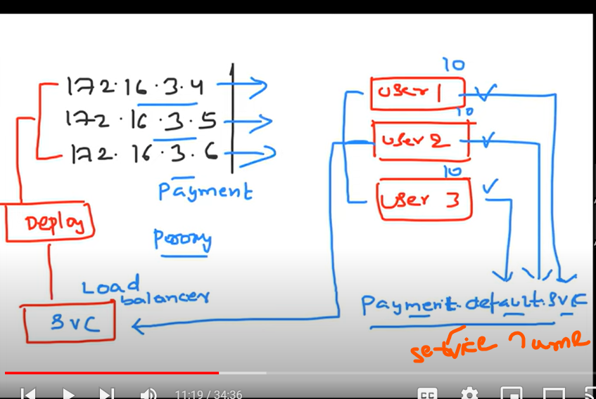

1. **Services resolve the second problem is service discovery**, Services uses the **label** name instead of ip address, kubernetes uses the same yaml file while generating the new pod created, so service introduced **label and selectors concept.**

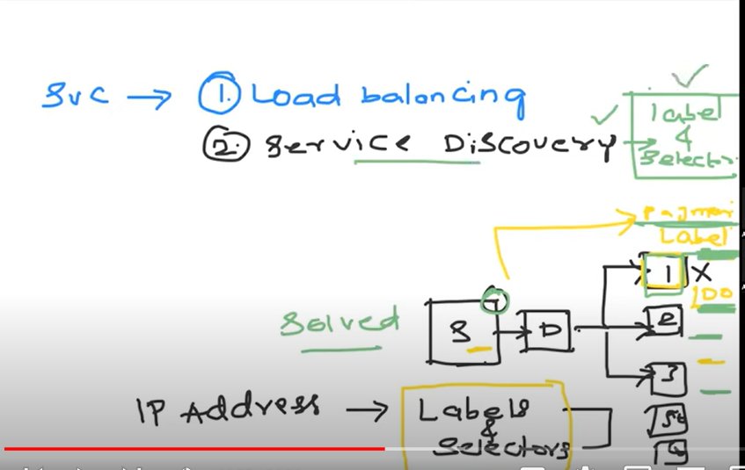

**Labels and Selectors concept:**

Uses the yaml manifest and deploy the pods, when create new pod , service will be using the label, instead of ip address, so number of times the pod is created, ip address will changes , but service will use the label name, so service discovery solve the second problem,.

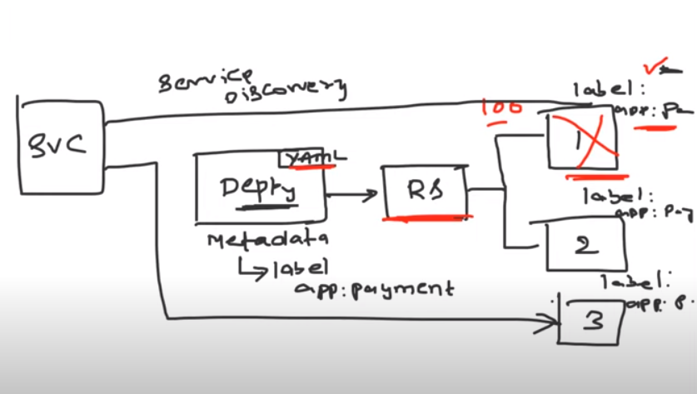

1. **Service expose to external world:**

**Outside world access to your application, they can’t directly access to you application, so service expose introduced Yaml manifest.**

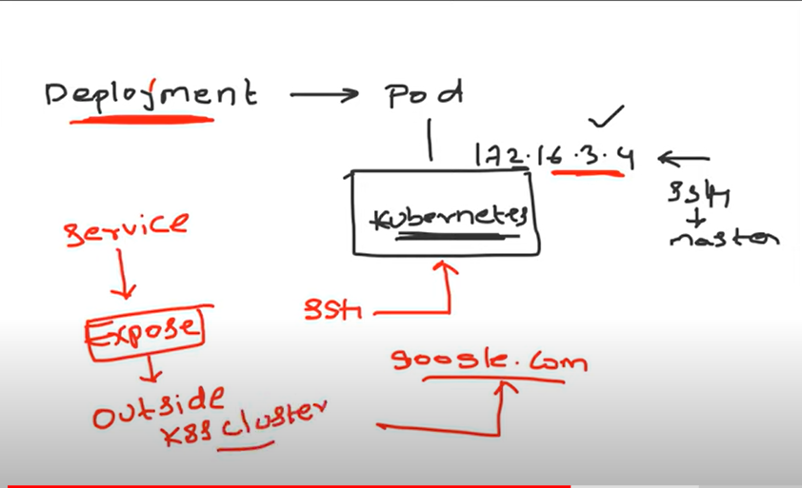

**YAML service can 3 types are default**

1. **Cluster IP🡪inside the cubernetes cluster (who ever access the cubernetes access , that one can access), two more benefit are discovery and loadbalancing.**
2. **Node Port-🡪inside your organization access the application or within your network or who have the access the node ip address**
3. **Load balancing -🡪Service will expose to external world on your cloud provider.**

**If you are creating service load balancer type as EKS, then you will get the ELB for your specific service, they can use the use the public ip address and use it anywhere in the world.**

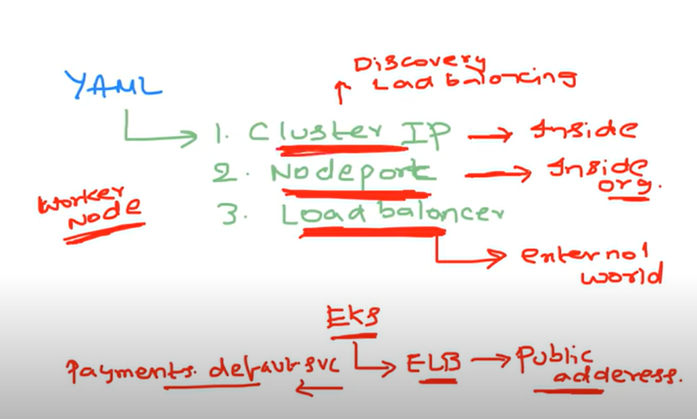

**Kubernetes cluster has worker node1 has worker node has 3 pods, Deployement, Replica set and Pod and top of the worker node service is created.**

**1)service creates the cluster IP mode, whoever access to kubernetes cluster access can access this Cluster IP mode.**

**Ex : public user has organization access, but user can’t access the application.**

**2) Load balancer : the cluster on AWS, kubernetes cluster notifies that EKS, I have load balance service type, so can you give me a loadbalnace ip address which means public ip address.**

**Cloud control Managder (this is part of Cubernetes master node), cloud control manager generates the public ip address using AWS implementation will return public ip address**

**3)Node port mode: whoever access to worker noded1, node2 , node3 or whoever access to EC2 instances access they can access me.**

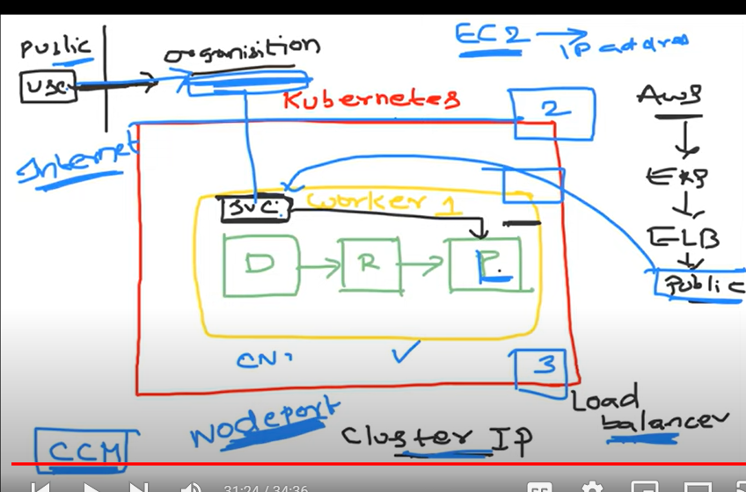

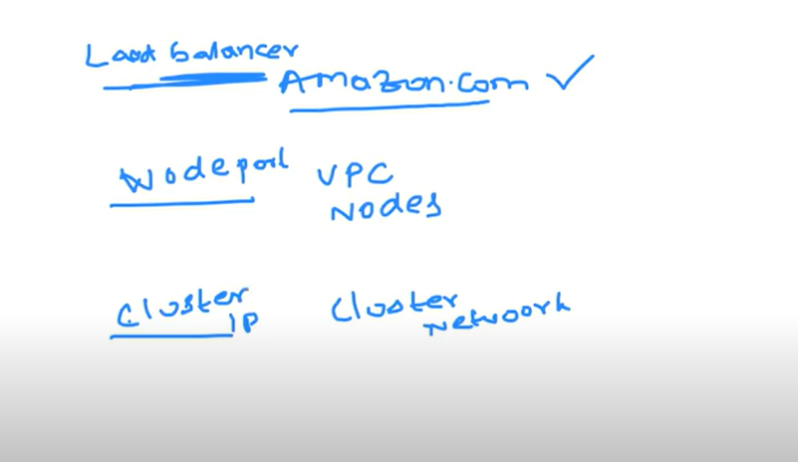

**Day 38**

**Ingress::::**

**Ingresss came into makert after 215, before 2015 people using the services only.**

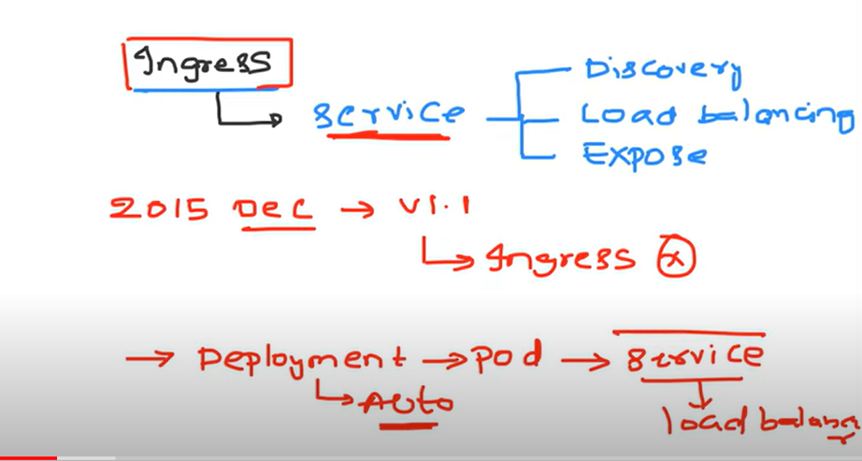

**The people were happy after moving from VM/Physical servers to Kubernetes concept**

**They used to VM/physical servers ontop of load balancing (nginix, F5)**

**They offer enterprise loadbalancing are**

**Ratio based load balancing (ex :send 3 rqeusts first node, sendo 5 reqeust to second node)**

**Stickey sessions (ex :one specific request to goto node1 only, specific user request goto same node1 only)**

**Path based**

**Domain hostbased**

**Whitelisiting (they allow specific customers to allow the applications)**

**Blacklisting(they don’t allow to specific customers)**

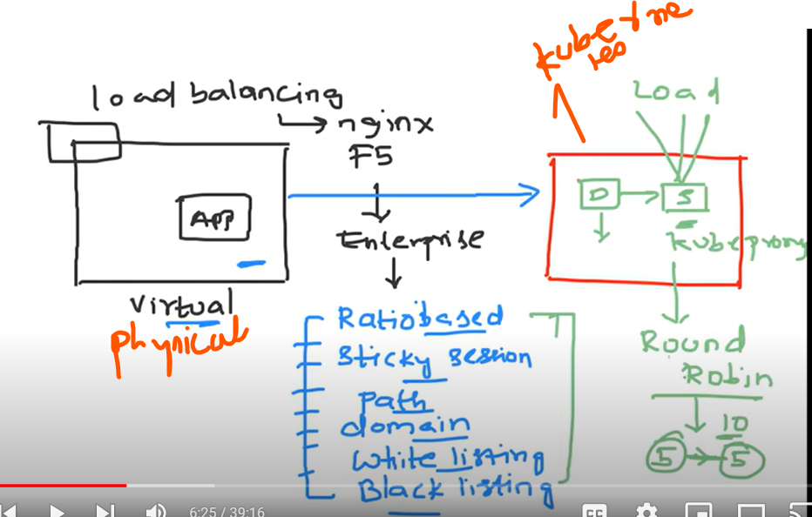

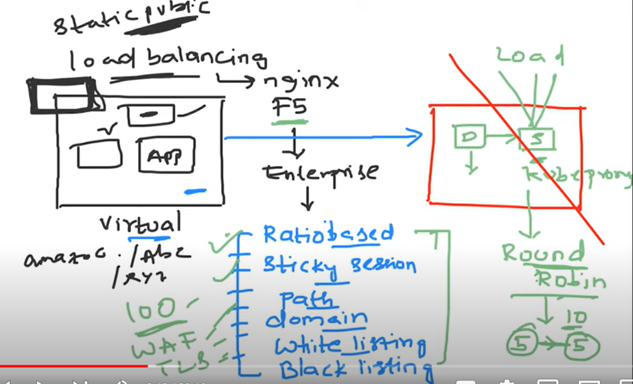

**Afer few time/years they realized kubernetes service proivedes the round roubin uses to send suppose totaol 10 reqeust, 5 requests send to node1 and 5 reqeusts send to node2**

**Kubeproxy updating your ip table rule.**

**Second problem is load balancer mode**

**Here VM/physical they used one loadbalancing with static public ip address**

**If company uses 1000 of services and they have to use the microservices , whey they creates loadbalncing , cloud provider changed for each and every static public ip address**

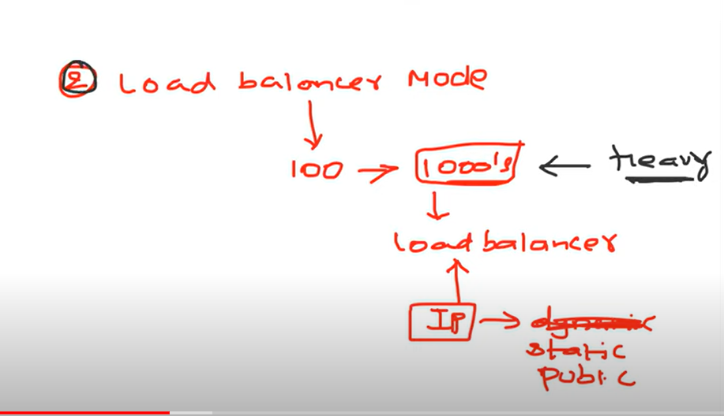

**Problems after moveing from physical/vm to kubernetes**

**1)enterprises and TLS load balance**

**2) loadbalncer🡪 cloud prvider charge for each service load balancing ip address**

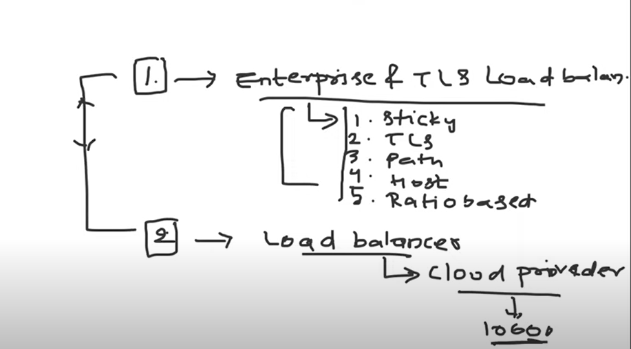

**Kubernetes accepted loadbalancing capabilities issues compare to VM/Physical used loadbalncing**

**So Kubernetes introduced ingress resource**

**Kubernetes suggested you use ingress controller snix or f5 (loabalancing )yaml file deploy to kubernetes, then devop engineer writes ingress yaml file on the kubernetes services**

**Ingress controller watch for the ingress resource and create the path based routing**

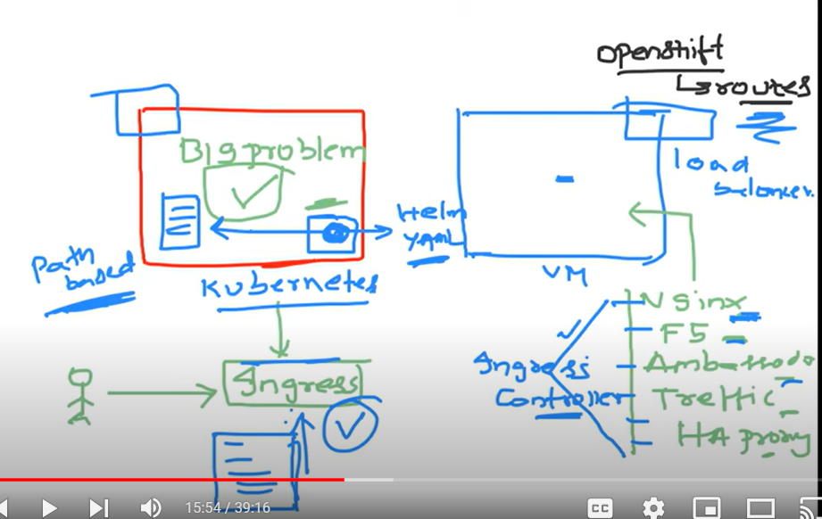

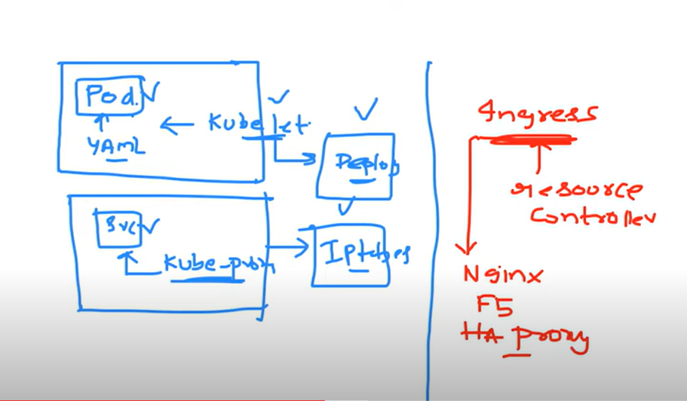

**Loadbalnceing companies (nginx, f5) write their own ingress controller and place their ingress controller on github and they will provide the steps how to install ingress controller, so user the choose correct ingress contoller and deploy to kubernetes, the ingress controller is nothing but loadbalancer**

**Ingress controller (ngnix or f5) first deply yaml file to kubernetes and creates ingress (pathbased or TLS)**

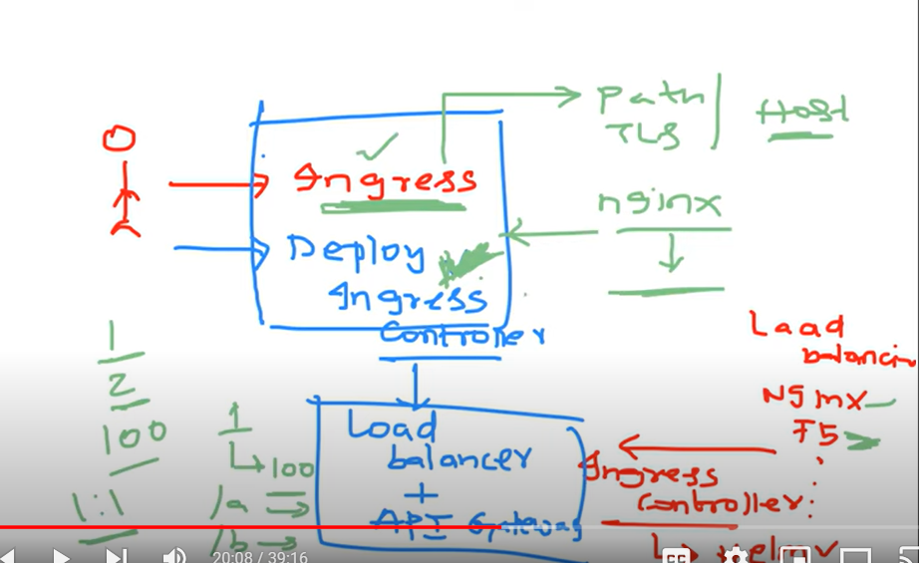

**The below problem solved by igress**

**1)Kibernetes service Enterprises does not have that much capabilities (loadbalancing, security)**

**2)Cloud provider charged for each service statcic ip address**

**Goto kibernetes cluster and find your ingress example yaml file and create ingress resource nothing will happened.**

**Ingress controller is nothing but loadbalncer choose from requirement (nginix or f5 or ha proxy)**

**Once you create the ingress resources on the kubernetes cluster they will watch for ingress resources and they will privde the required capabilities (pathased, hostbsed)**

